Student Management Sprint 2
To create the login page and monthly char page I have only use Boot strap and some inline css.
Screen Shots:
Login Page:
1.User cannot login without Registering:
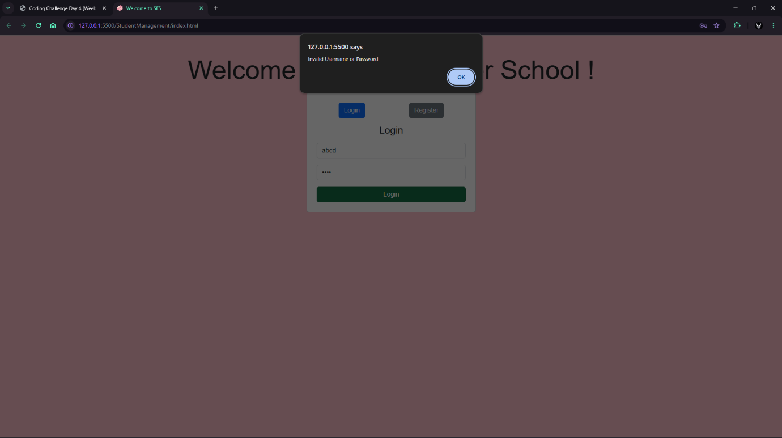
2. User can login after Register
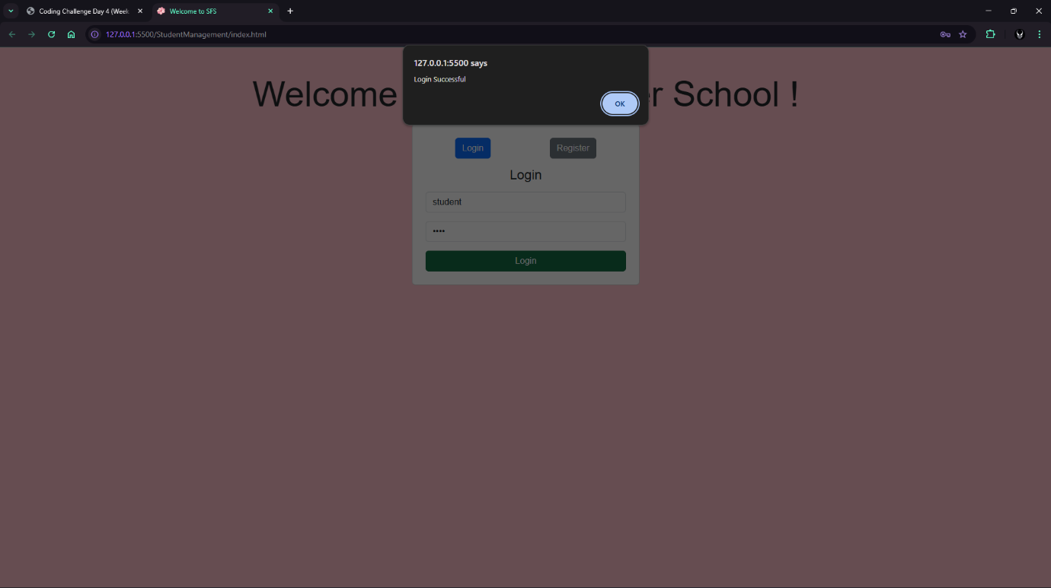
Register Page:

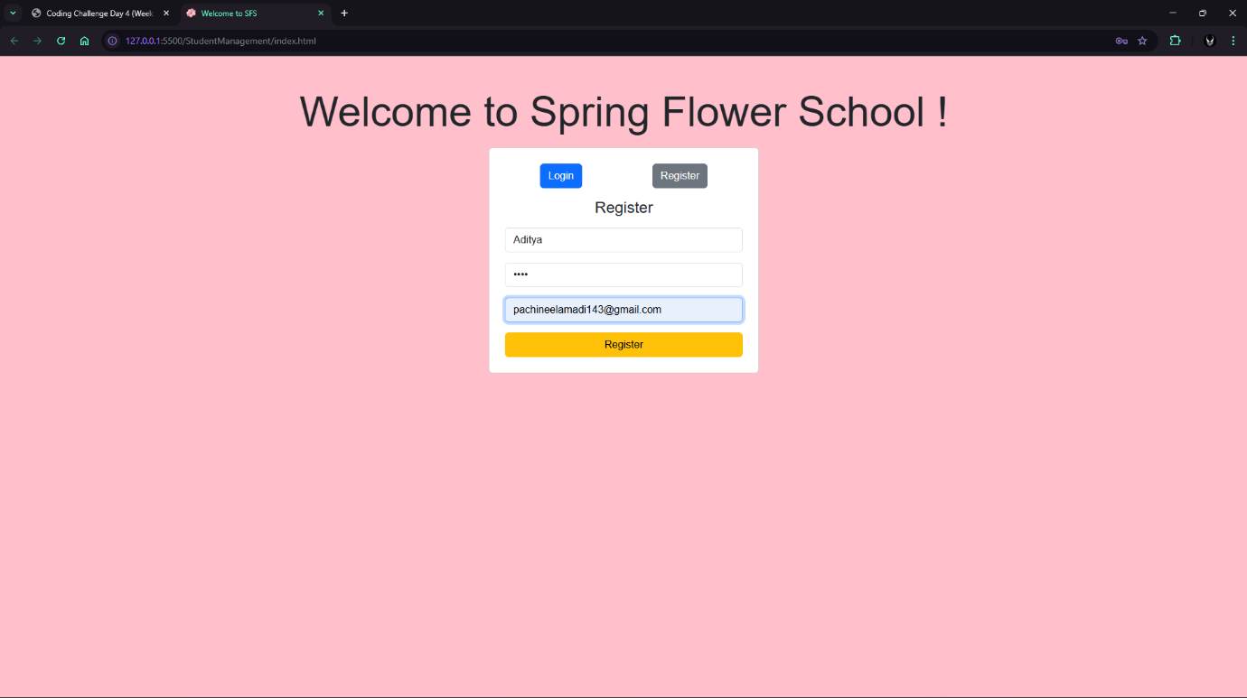

Registered Successfully:
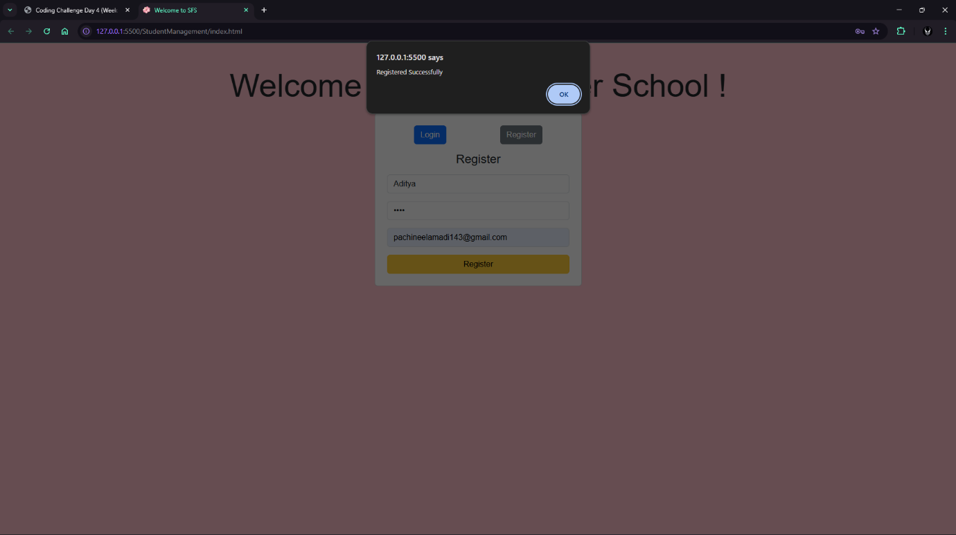

Home Page with Monthly Chart in the Menu:

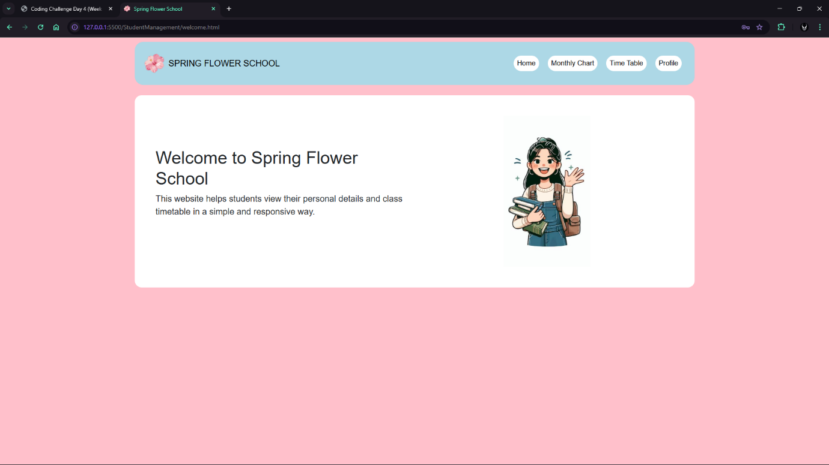

Monthly Activity Page with Selectable Drop Down:

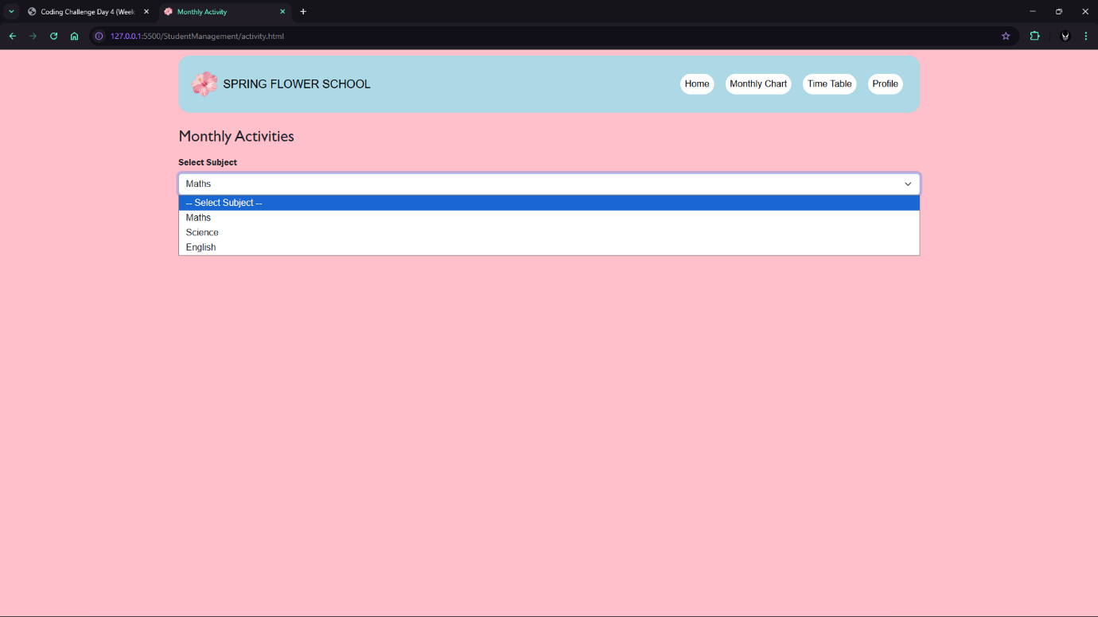
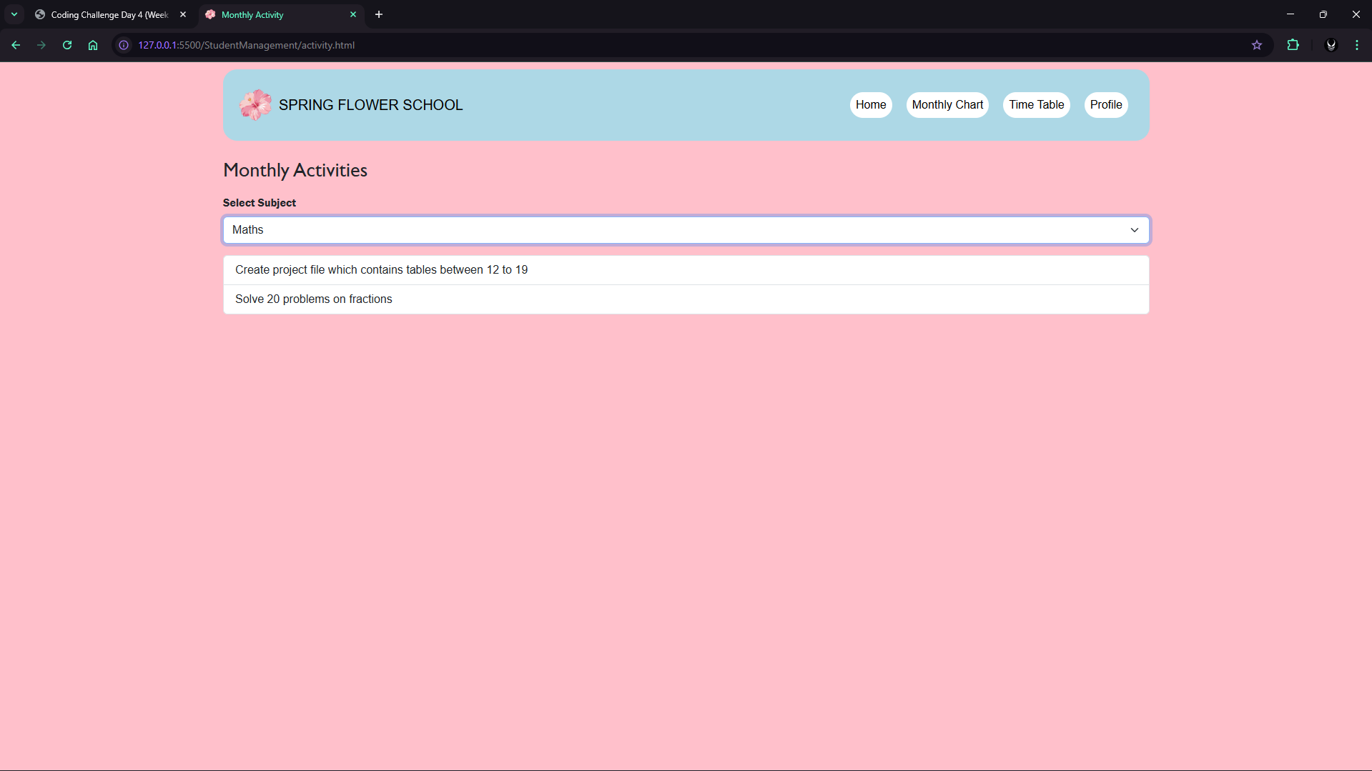

Mobile Screen Shots:
Login page: Home page: Activity Page:
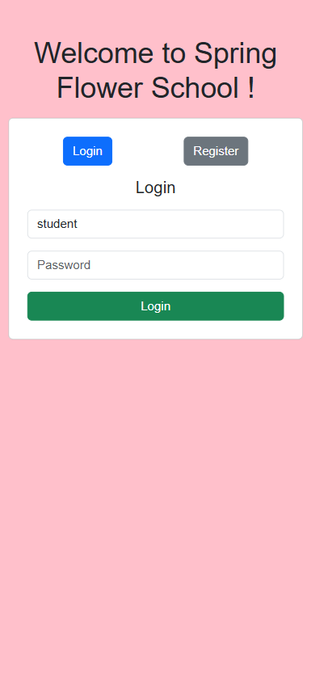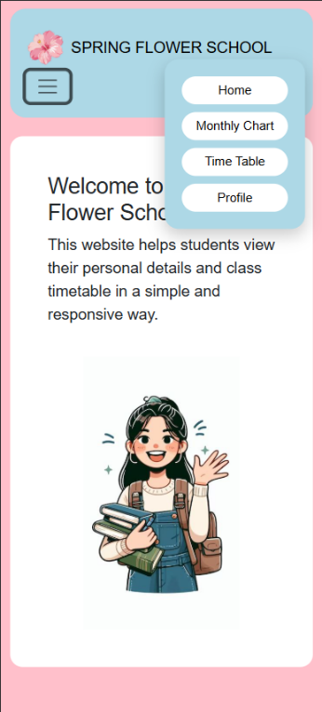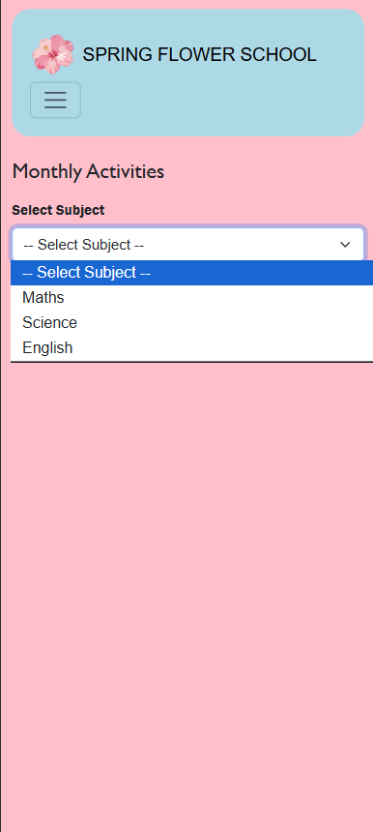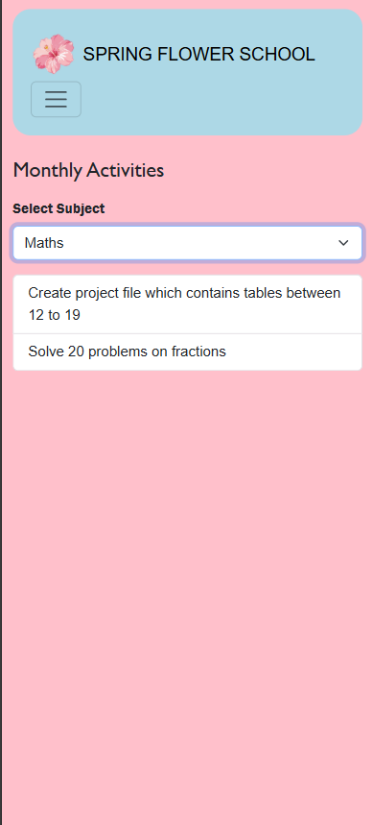

index.html:
<!DOCTYPE html>
<html lang="en">
<head>
<meta charset="UTF-8" />
<meta name="viewport" content="width=device-width, initial-scale=1.0" />
<title>Welcome to SFS</title>
<link rel="icon" href="./Images/SpringLogo.png" />
<link
href="https://cdn.jsdelivr.net/npm/bootstrap@5.3.3/dist/css/bootstrap.min.css"
rel="stylesheet"
/>
<script src="./script.js"></script>
<link rel="stylesheet" href="./styles.css">
</head>

<body>
<div class="container mt-5">
<p class="display-3 text-center">Welcome to Spring Flower School !</p>
<div class="row justify-content-center">
<div class="col-md-4">

<div class="card p-4">
<div class="d-flex justify-content-around mb-3">
<button class="btn btn-primary" onclick="showLogin()">Login</button>
<button class="btn btn-secondary" onclick="showRegister()">Register</button>
</div>
<div id="loginForm">
<h4 class="text-center mb-3">Login</h4>
<input type="text" id="loginUser" class="form-control mb-3" placeholder="Username"/>

<input
type="password"
id="loginPass"
class="form-control mb-3"
placeholder="Password"
/>

<button class="btn btn-success w-100" onclick="login()">
Login
</button>
</div>
<div id="registerForm" style="display:none;">
<h4 class="text-center mb-3">Register</h4>
<input
type="text"
id="regUser"
class="form-control mb-3"
placeholder="Username"
/>
<input
type="password"
id="regPass"
class="form-control mb-3"
placeholder="Password"
/>
<input
type="email"
class="form-control mb-3"
placeholder="Email"
/>
<button class="btn btn-warning w-100" onclick="register()">
Register
</button>
</div>

</div>

</div>
</div>
</div>

</body>
</html>

Script.js:
let users = [
{ username: "student", password: "1234" }
];

function showLogin() {
document.getElementById("loginForm").style.display = "block";
document.getElementById("registerForm").style.display = "none";
}

function showRegister() {
document.getElementById("loginForm").style.display = "none";
document.getElementById("registerForm").style.display = "block";
}

function register() {
let user = document.getElementById("regUser").value;
let pass = document.getElementById("regPass").value;

if (user === "" || pass === "") {
alert("Please fill all fields");
return;
}
users.push({ username: user, password: pass });
alert("Registered Successfully");
showLogin();
}

function login() {
let user = document.getElementById("loginUser").value;
let pass = document.getElementById("loginPass").value;

let valid = false;

for (let i = 0; i < users.length; i++) {
if (users[i].username === user && users[i].password === pass) {
valid = true;
break;
}
}

if (valid) {
alert("Login Successful");
window.location.href = "welcome.html";
} else {
alert("Invalid Username or Password");
}
}

activity.html:
<!doctype html>
<html lang="en">
<head>
<meta charset="UTF-8" />
<meta name="viewport" content="width=device-width, initial-scale=1.0" />
<title>Monthly Activity</title>
<link rel="icon" href="./Images/SpringLogo.png" />
<link
href="https://cdn.jsdelivr.net/npm/bootstrap@5.3.3/dist/css/bootstrap.min.css"
rel="stylesheet"
/>
<script src="https://cdn.jsdelivr.net/npm/bootstrap@5.3.3/dist/js/bootstrap.bundle.min.js"></script>
<link rel="stylesheet" href="./styles.css" />
<script src="./script.js"></script>
</head>
<body>
<header>
<div class="container">
<nav class="navbar navbar-expand-md navbar-light" style="padding: 20px">
<a
class="navbar-brand d-flex align-items-center gap-2"
href="index.html"
>
<img src="./Images/SpringLogo.png" height="50" />
<span>SPRING FLOWER SCHOOL</span>
</a>
<button
class="navbar-toggler"
data-bs-toggle="collapse"
data-bs-target="#mainMenu"
>
<span class="navbar-toggler-icon"></span>
</button>
<div class="collapse navbar-collapse" id="mainMenu">
<ul class="navbar-nav ms-auto">
<li class="nav-item">
<a class="nav-link active" href="welcome.html">Home</a>
</li>
<li class="nav-item">
<a class="nav-link" href="activity.html">Monthly Chart</a>
</li>
<li class="nav-item">
<a class="nav-link" href="timetable.html">Time Table</a>
</li>
<li class="nav-item">
<a class="nav-link" href="profile.html">Profile</a>
</li>
</ul>
</div>
</nav>
</div>
</header>
<main class="container my-4">
<h3 class="mb-3" style="font-family: 'Gill Sans', 'Gill Sans MT', Calibri, 'Trebuchet MS', sans-serif;">Monthly Activities</h3>

<div class="mb-3">
<label class="form-label" style="font-family: 'Franklin Gothic Medium', 'Arial Narrow', Arial, sans-serif;">Select Subject</label>
<select class="form-select" id="subjectSelect">
<option value="">-- Select Subject --</option>
<option value="Maths">Maths</option>
<option value="Science">Science</option>
<option value="English">English</option>
</select>
</div>
<ul class="list-group" id="activityList"></ul>
</main>
<script>
const monthlyActivities = [
{
id: 1,
activity: "Create project file which contains tables between 12 to 19",
subject: "Maths"
},
{
id: 2,
activity: "Solve 20 problems on fractions",
subject: "Maths"
},
{
id: 3,
activity: "Prepare chart on Solar System",
subject: "Science"
},
{
id: 4,
activity: "Write notes on Human Digestive System",
subject: "Science"
},
{
id: 5,
activity: "Write an essay on My Best Friend",
subject: "English"
}
];

const subjectSelect = document.getElementById("subjectSelect");
const activityList = document.getElementById("activityList");
subjectSelect.addEventListener("change", function () {
const selectedSubject = this.value;
activityList.innerHTML = "";

const filteredActivities = monthlyActivities.filter(
act => act.subject === selectedSubject
);
if (filteredActivities.length === 0) {
activityList.innerHTML = `<li class="list-group-item">No activities found</li>`;
return;
}
filteredActivities.forEach(act => {
const li = document.createElement("li");
li.className = "list-group-item";
li.textContent = act.activity;
activityList.appendChild(li);
});
});
</script>

</body>
</html>

